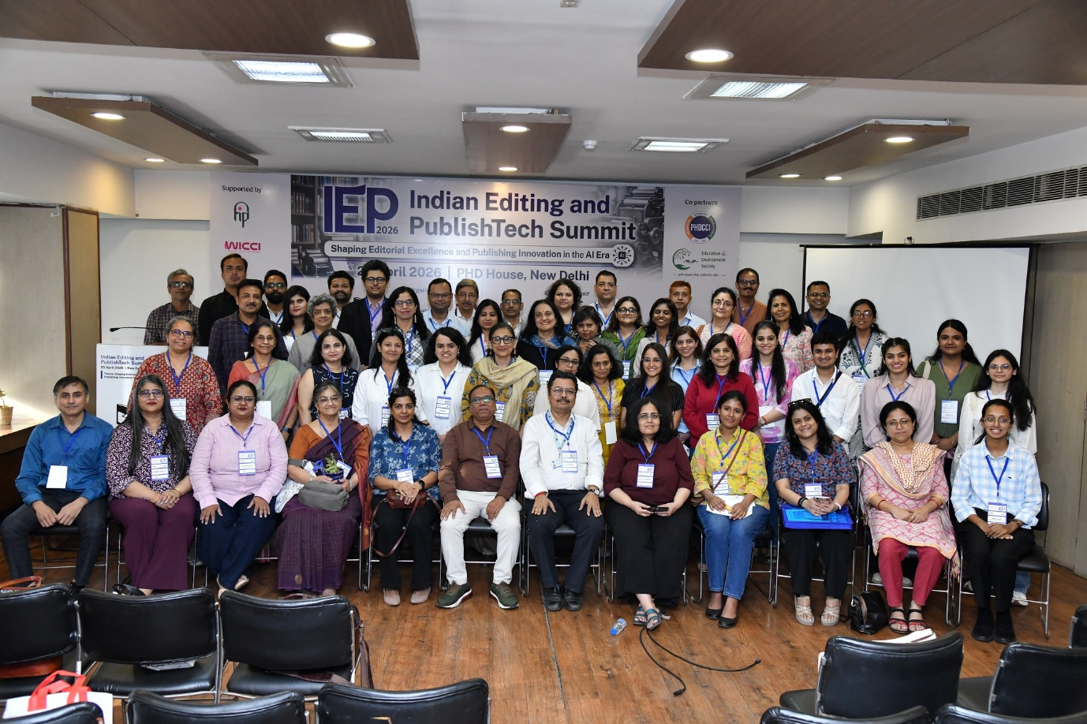

PRESS RELEASE

IEP Summit 2026 Concludes with Grand Success; Brings Together India’s Editorial and Publishing Leaders in the AI Era

A Landmark Gathering of Editors, Publishers, Academicians, and AI Innovators at New Delhi
New Delhi, 25 April 2026:
The Indian Editing and PublishTech Summit (IEP Summit 2026) concluded with resounding success at PHD House, New Delhi, marking a significant milestone for India’s editorial, publishing, and content technology ecosystem.
Organized by the Indian Copyeditors Forum (ICF) in collaboration with Business Media Links (BML), along with support from the Freelance Foundation, Federation of Indian Publishers (FIP), PHD Chamber of Commerce & Industry and Education & Environment Society (EES), and WICCI National Media Council, the summit emerged as a powerful platform for knowledge exchange, networking, and industry alignment.
Centered on the theme “Shaping Editorial Excellence and Publishing Innovation in the AI Era,” the summit brought together a dynamic mix of industry leaders, editors, publishers, academicians, AI experts, and independent professionals.

Strong Opening with Visionary Leadership
The summit commenced with a welcome address by Mr. Vivek Kumar, Founding Member of ICF, who emphasized the need for editorial professionals to adapt to technological disruption while preserving editorial integrity.
The keynote by Mr. Sreetilak Sambhanda, Director Publishing, Viva Books Pvt. Ltd., set the tone by highlighting the essential mindset shifts required for an AI-driven editorial future, urging professionals to embrace AI as an enabler rather than a threat.

High-Impact Sessions Led by Industry Experts
The conference featured insightful sessions from leading experts:
- Ms. Malobika Chakraborty (Manager, Portfolio Management, Pearson) discussed evolving editorial workflows in the AI era
- Ms. Meru Gokhale (Founder and CEO, Editrix) shared practical strategies for AI integration in editing
- Ms. Dola Basu Singh (Editor, Author, and Writing Coach) explored narrative development in AI-assisted fiction
- Ms. Supriya Thanawala (Production Editor, Westchester Publishing Services) spoke on sustainable editing practices
- Ms. Anitha Kumaran (Program Leader and Product Strategist, IKomet) addressed AI-driven publishing infrastructure

Key Panel Discussions
A major highlight was the panel moderated by Mr. Manish Purohit (Director, AuthorsUpFront) on “Challenges and Opportunities in Publishing in the AI Era,” featuring the following as copanelists:
- Ms. Chandni Mathur (Founder, Wordly Wise Publishers)
- Mr. Sanjay Kumar (Publisher, Excel India Publishers & COO, Group Excel India)
- Ms. Renu Kaul Verma (MD and Publisher, Vitasta Blackspine Publishing Group)
Another engaging panel on editorial hiring trends was moderated by Ms. Abha Thapalyal Gandhi (Senior Partner, The Legal Watch), featuring the following as copanelists:
- Dr. Shalini Mullick (Award-winning Author and Pathologist)
- Mr. Dharmesh Patnaik (General Manager – Editorial Services, Aptara)
- Ms. Renu Kaul Verma (MD and Publisher, Vitasta Blackspine Publishing Group)

Distinguished Participation from Leading Organizations
The summit witnessed participation from top-tier organizations across publishing, education, content, and technology sectors, including:
Pearson, Aptara, Viva Books, Vitasta Publishing, Excel India Publishers, Wordly Wise Publishers, Westchester Publishing Services, Editrix, IKomet, TNQ Technologies, Lumina Datamatics, KnowledgeWorks Global, Macmillan Education India, S Chand & Company Ltd., Vikas Publishing House, Orient Blackswan, Jaypee Brothers Medical Publishers, Extramarks, NCERT, Physics Wallah, Fujitsu Consulting, TRAI, Social Axiom Foundation (Project CRADLE), and Tranistics Data Technologies Pvt. Ltd.
Media and ecosystem representation included exchange4media (e4m) and Business World, along with strong institutional presence from PHD Chamber of Commerce & Industry.

Notable Attendees & Industry Professionals
The event saw participation from a highly accomplished audience, including:

Senior Professionals and Industry Experts
- Ms. Nandini Gupta – Senior Copyeditor (LearningMate)
- Ms. Hina Hussain – Content Developer (Extramarks)
- Ms. Garima Syal – Assistant Editor (NCERT)
- Ms. Tanushree Gupta – Team Lead, Instructional Design & Technical Writing
- Ms. Ambalika Raha – Manager, Technical Writing (Fiserv)
- Ms. Sheela Roy – Senior Editor
- Mr. Giri Ramamurthy – General Manager, Lumina Datamatics
- Ms. Rajalakshmi K – AVP, R&D, TNQ
- Dr. Lucy Shaily – Editorial Manager, Project CRADLE
- Mr. Vishwendra Pundir – Senior Manager, Aptara
- Ms. Shaivya Saksena – Deputy Managing Editor, Macmillan Education India
- Ms. Annie George – Senior Managing Editor, Vikas Publishing House Pvt. Ltd.
- Ms. Nisha Roy Chowdhury – Assistant Publisher (Indian Languages), Orient Blakswan
- Mr. Udoy Bhaskar, Publishing Manager, S. Chand and Company Limited
- Mr. Shyaloo Dhama – Business Head, Publishing (Prints Publications)
- Ms. Sunita Dogra, Technical Editor and Writer, Fujitsu Consulting

Leading Freelancers, Consultants, and Independent Experts
A strong presence of India’s growing freelance editorial ecosystem added significant value:
- Ms. Preeta Priyamvada, Freelance Editor
- Ms. Shruti Sinha – Freelance Copyeditor and Proofreader, The Green Pencil Editorial Services
- Ms. Abha Agarwal – Publishing and Editorial Consultant
- Ms. Sucheta Das Mohapatra – Independent Communication and Content Consultant
- Ms. Vandana Kumari – Freelance Medical and Copy Editor
- Ms. Kakoli Sajwan – Freelance Editor
- Ms. Inderpreet Kaur Uppal – Freelance Fiction Copyeditor
- Mr. Anupam Choudhury – Consulting Copyeditor
- Ms. Tavleen Kaur – Freelance Editor
- Mr. Manoj Bachheti – Freelance Copyediting Consultant (Textmend)
- Ms. Ankita Gupta – Freelance Editor
- Ms. Ananya Bhatia – Independent Editor
- Mr. Sanjiv Sarin – Freelance Editor

Entrepreneurs, Founders, and Consultants
- Ms. Rachna Rohatgi, Author and Curriculum Developer
- Ms. Divya Jyoti Munjal – Independent Publishing Operations Consultant
- Ms. Lubna Duggal – Senior Consultant / Associate Editor

Key Insights from the Summit
- AI is transforming publishing but human editorial expertise remains central
- New roles are emerging in AI-assisted editing, prompt engineering, and content validation
- Ethical publishing, research integrity, and content authenticity are more critical than ever
- The future lies in collaboration between technology and human creativity

A Powerful Platform for the Editorial Ecosystem
The IEP Summit 2026 successfully created a first-of-its-kind collaborative ecosystem bringing together traditional publishing, digital content, and AI innovation under one roof.
The event facilitated meaningful discussions, networking, and strategic collaborations, positioning itself as a must-attend annual platform for the editorial and publishing fraternity.

Looking Ahead – Bigger 2nd Edition Announced
Encouraged by the overwhelming response, the organizers announced that the 2nd Edition of IEP Summit will be launched soon, with expanded participation, deeper industry engagement, and enhanced global outlook.

Acknowledgement
The Organizing Committee extends sincere gratitude to all speakers, delegates, partners, and contributors for making the summit a grand success.

Media Contact
Shailendra Kumar
Project Director – IEP Summit 2026
Business Media Links (BML)
📧 sk@bmlindia.in
📞 +91-9868332325
📸 Photos:
https://photos.app.goo.gl/1vDrTCsmHDZ5xX1U6
🎥 Video:
https://drive.google.com/file/d/1kGjFYaDdzgW7eL6NdIeaTUAfL_ADa7WA/view

